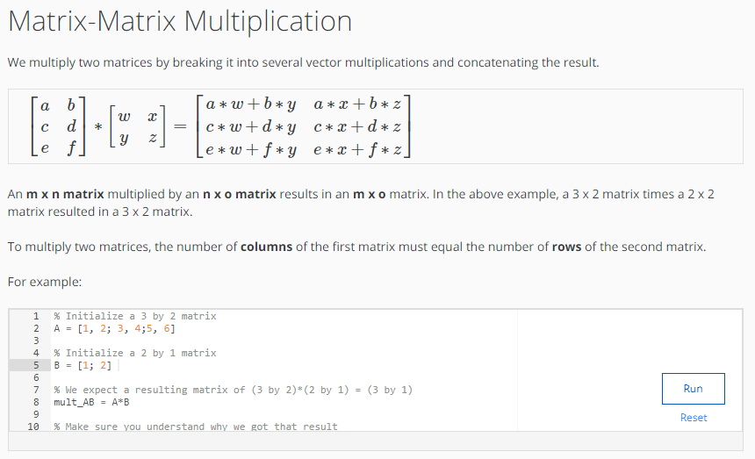

CODE:
% Initialize a 3 by 2 matrix
A = [1, 2; 3, 4;5, 6]

% Initialize a 2 by 1 matrix
B = [1; 2]

% We expect a resulting matrix of (3 by 2)*(2 by 1) = (3 by 1)
mult_AB = A*B

% Make sure you understand why we got that result

OUTPUT:
